ComicsWorld

**Use-Case Specification**

**Version 1.**1

**Revision History**

| **Date** | **Version** | **Description** | **Author** |
| --- | --- | --- | --- |
| 15/07/2023 | 1.0 | Update use case model | Phạm Phú Toàn  Ngô Quốc Quý  Nguyễn Thuận Phát  Nguyễn Trần An Hòa  Tô Khánh Linh |
| 21/07/2023 | 1.1 | Update use case specification | Phạm Phú Toàn  Ngô Quốc Quý  Nguyễn Thuận Phát  Nguyễn Trần An Hòa  Tô Khánh Linh |

**Table of Contents**

**1. Use-Case Model 4**

**2. Use-Case Specification 5**

2.1 Use-Case Sign up 5

2.2 Use-Case Login 5

2.3 Use-Case Read Comic 6

2.4 Use-Case Search Comic 7

2.5 Use-Case Report Comics 8

2.6 Use-Case Comment 8

2.7 Use-Case Follow Comics 9

2.8 Use-Case Rating: 10

2.9 Use-Case Manage Account 10

2.9.1 Use-Case Ban Account 10

2.9.2 Use-Case Change Roles 11

2.10 Use-Case Manage Comic 12

2.10.1 Use-Case Remove comics 12

2.10.2 Use-Case Upload comics by chapter 13

2.10.3 Use-Case Fix Comic 14

2.10.4 Use-Case Tracking View 15

2.10.5 Use-Case Read Report 16

2.10.6 Use-Case Create New Comic 16

**Use-Case Specification**

# Use-Case Model

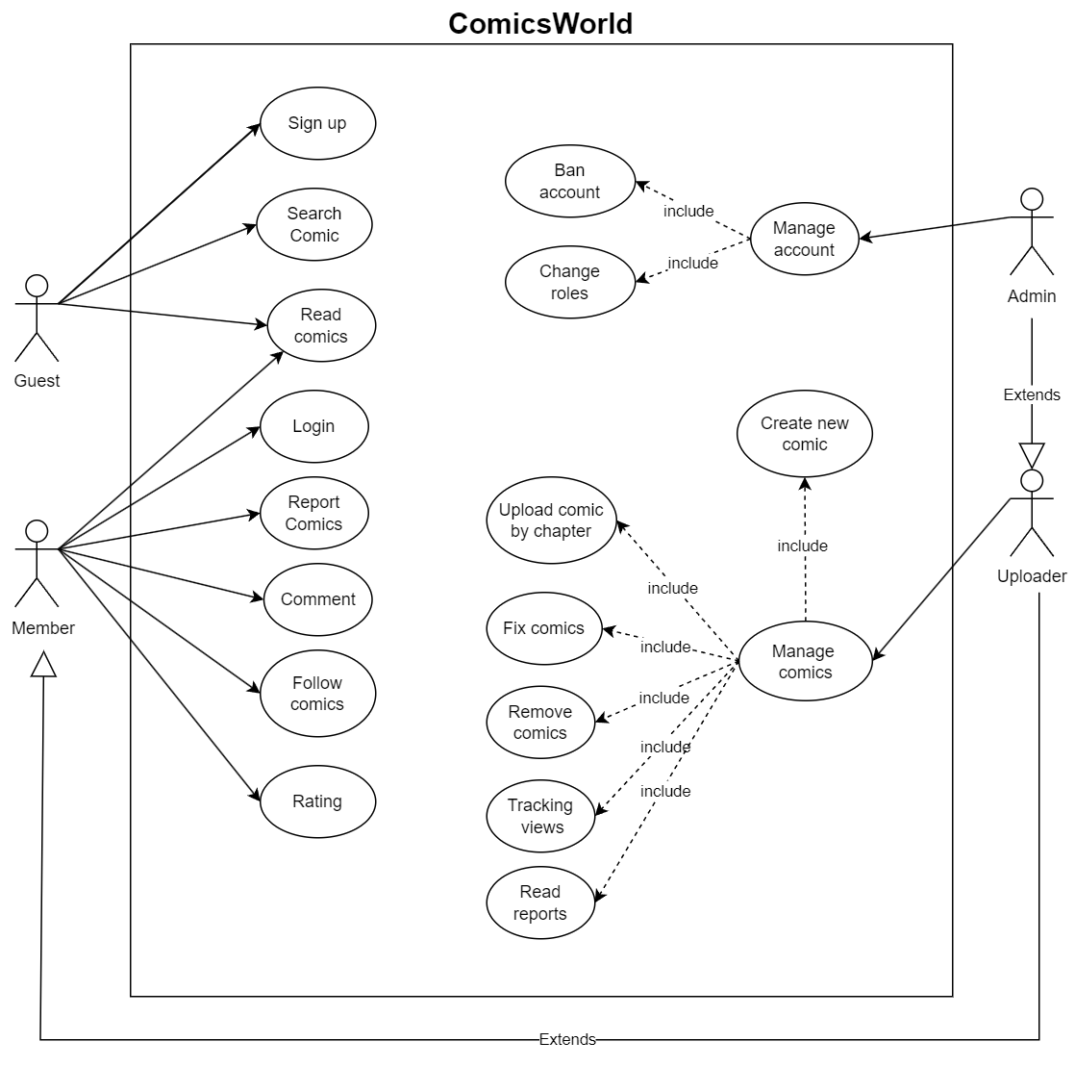

# Use-Case Specification

## Use-Case Sign up

| **Use-case ID** | 01 |
| --- | --- |
| **Use-case name** | Sign up. |
| **Brief description** | This use case describes how the user can sign up to create a new account to enter the website. |
| **Actors** | Guest. |
| **Pre-condition** | Users open the website. |
| **Basic flow** | **Step 1:** Users click on the ‘login/register’ button on the screen.  **Step 2:** System prompts the user for a username and password or to register a new account.  **Step 3:** User selects the ‘registration’ button.  **Step 4:** The System prompts users for registration information: name, username, password, password confirmation.  **Step 5:** The user enters their information.  **Step 6:** System verifies information and creates an account. |
| **Alternative flow** | **Alternative flow 1: Cancel registration**   1. At any step, The user returns to the previous page while entering the information. 2. The system returns the user to the home page without creating a new account and any information entered will be erased.   **Alternative flow 2: Invalid information entered**   1. At step 5, the system will return a pop up notification with appropriate messages to correct invalid information. 2. Click ok to close the pop up. 3. User re-enters information. |
| **Post-condition** | **Post-condition 1: If successful**  The user gets a notification of successful sign up, the system will log in for the user and return the user to the homepage.  **Post-condition 2: If unsuccessful**  User is unable to sign up for one or more reasons and is returned to the sign up page. |

## Use-Case Login

| **Use-case ID** | 02 |
| --- | --- |
| **Use-case name** | Login. |
| **Brief description** | This use case describes how the user logs in to the account. |
| **Actors** | Member. |
| **Pre-condition** | User opens the website and already has an account in the website’s database. |
| **Basic flow** | **Step 1:** User clicks on the ‘login/register’ button on the screen.  **Step 2:** System prompts the user for a username and password.  **Step 3**: User enters their information.  **Step 4:** User selects the ‘login’ button.  **Step 5:** System checks the database whether the account exists.  **Step 6:** System displays successful login notification and returns to home page. |
| **Alternative flow** | **Alternative flow 1: Cancel while login**   1. At step 3, The user returns to the previous page while entering the information. 2. The system returns the user to the home page without the user being logged in.   **Alternative flow 1: No information entered**   1. At step 4, the system will send a notification pop up of empty input and suggest the user to enter again. 2. The user clicks ok to close the pop up. 3. Return to step 3. |
| **Post-condition** | **Post-condition 1: If successful**  The system will return the notification of successful login and return to the homepage.  **Post-condition 2: If unsuccessful**  The system will return the notification of unsuccessful login and return to the login page. |

## Use-Case Read Comic

| **Use-case ID** | 03 |
| --- | --- |
| **Use-case name** | Read comics. |
| **Brief description** | This use case describes how the user reads the comics. |
| **Actors** | Member, Guest. |
| **Pre-condition** | User opens the website. |
| **Basic flow** | **Step 1:** The user chooses the comics they want to read by finding it at the homepage or what they have searched or in their favorite list.  **Step 2:** The user can choose whether to read at the beginning or scrolling down to find a specific chapter.  **Step 3:** The user clicks on what they want.  **Step 4**: The chapter which is chosen is displayed.  **Step 5:** The user reads the comic by scrolling.  **Step 6:** The user can change the chapter to the next/previous/specific chapter at the end/beginning of the chapter. |
| **Alternative flow** | **Alternative flow 1: Change chapter while reading.**   1. At step 5, while in the middle of the page we can press the ‘back to the top’ button to go to the top of the page where the navigation bar is located and then change the chapter. |
| **Post-condition** | **Post-condition 1:** The system will record the view of the user then add to the amount of views the comic has. |

## Use-Case Search Comic

| **Use-case ID** | 04 |
| --- | --- |
| **Use-case name** | Search comics. |
| **Brief description** | This use case describes how the user searches for the comic they want to read. |
| **Actors** | Guest, Member |
| **Pre-condition** | User opens the website. |
| **Basic flow** | **Step 1:** The user clicks on the search bar.  **Step 2:** The system will recommend the keywords most searched lately.  **Step 3:** System prompts the user for a name of the comics.  **Step 4:** User enters the comic name or chooses what the system recommends.  **Step 5:** The System will find the comic in the database and return the related result. |
| **Alternative flow** | **Alternative flow 1: No information entered**   1. At step 4 the system will send a pop up notification of the user's empty input and require the user to enter the keywords again. |
| **Post-condition** | **Post-condition 1: If successful**  The system returns the comic that the user was searching for, the system will record what has been searched so that it can recommend it to the user.  **Post-condition 2: If unsuccessful**  The system will return the notification of no result found. |

## Use-Case Report Comics

| **Use-case ID** | 05 |
| --- | --- |
| **Use-case name** | Report Comics |
| **Brief description** | Users report a comic or comment if it is inappropriate(copyright infringement, contain baxd words,...) |
| **Actors** | Member |
| **Pre-condition** | User logged in  User is at reading page |
| **Basic flow** | **Step 1:** At the reading page, users click the report button under the comic cover picture or the report button under the comment  **Step 2:** The system show a form for users to fill in  **Step 3:** Users write the reason why they reported  **Step 4:** Users click the send button  **Step 5:** The system shows a message to announce that the report is successfully sent |
| **Alternative flow** | **Alternative flow 1: User cancels the report**   1. From step 3, users click the cancel button beside the send button to cancel reporting   **Alternative flow 2: User leaves the form empty**   1. At step 3 users write nothing in the form 2. At step 4 users click send 3. At step 5 The system shows a message to notify users that their report is invalid instead. The report is not sent 4. Return to step 2, users have to fill in the form and sent again |
| **Post-condition** | **Success:** Users successfully sent the report  **Canceled:** Users return to the reading page |

## Use-Case Comment

| **Use-case ID** | 06 |
| --- | --- |
| **Use-case name** | Comment |
| **Brief description** | Members comment to express their feelings about the comic |
| **Actors** | Member |
| **Pre-condition** | User logged in  User is at reading page |
| **Basic flow** | **Step 1:** At the reading page,users scroll down to the comment section(at the bottom of the page) and click the box beside their avatar  **Step 2:** Users type their comments to the box  **Step 3:** Users click the send button to sent their comments |
| **Alternative flow** | **Alternative-flow 1: User writes nothing**   1. At step 2 the user writes nothing 2. At step 3 the user click the send button |
| **Post-condition** | **Sended:** The comment is shown in the comment section  **Empty:** The system adds nothing to the comment section. The comment section will not change |

## Use-Case Follow Comics

| **Use-case ID** | 07 |
| --- | --- |
| **Use-case name** | Follow Comics |
| **Brief description** | Members follow comics in order to get notifications about new chapters |
| **Actors** | Member |
| **Pre-condition** | User logged in |
| **Basic flow** | **Step 1:** At the home page,users find the comic they want to follow and click on it  **Step 2:** Users click the follow button under the comic cover picture  **Step 3:** The system shows a message to announce that the user is following that comic |
| **Alternative flow** | **Alternative-flow 1: User unfollows comics**   1. At step 2 users click the follow button once again 2. At step 3 The system shows a message to announce that the user unfollowed that comic instead |
| **Post-condition** | **Follow:** Users will receive notifications about the comic they followed  **Unfollow:** The system will not send notifications about the unfollowed comic to users |

## Use-Case Rating:

| **Use-case ID** | 08 |
| --- | --- |
| **Use-case name** | Rating |
| **Brief description** | Users who are members can rate the comics which they love. |
| **Actors** | Members |
| **Pre-condition** | Members logged in. |
| **Basic flow** | **Step 1:** Users scroll down to see the comics list at the homepage.  **Step 2:** Users choose any comics in the list.  **Step 3:** User clicks at the star under the comic title which wants to rate (scale 1 - 5 star). |
| **Alternative flow** | **Alternative-flow 1: Rate once**   1. At step 3, users are allowed to rate once per account. |
| **Post-condition** | **Post-condition 1: If successful**  The system will show the message which informs “Rating Successfully”.  **Post-condition 2: If unsuccessful**  The system will show the message which requires users to login to rate comics. |

## Use-Case Manage Account

### **Use-Case Ban Account**

| **Use-case ID** | 09 |
| --- | --- |
| **Use-case name** | Ban Account |
| **Brief description** | Admins manage the account, if there are any bad reports or bad comments, admins have the right to ban this account. |
| **Actors** | Admin |
| **Pre-condition** | Admin logged in. |
| **Basic flow** | **Step 1:** Admins choose “Manage Account” options from the admin's page.  **Step 2:** Click on the “Ban Account” button.  **Step 3:** Search the userID on the search bar.  **Step 4:** Click on the “Ban” button to ban accounts. |
| **Alternative flow** | **Alternative-flow 1: Cancel banning process**   1. At step 4, if the admin wants to cancel the process of banning, click on the “Cancel” button.   **Alternative-flow 2: Unban users**   1. At step 4, if the admin wants to unban the users, click on the “Unban” button. |
| **Post-condition** | **Post-condition 1: If banning successfully**  The system will show the message which informs “Banning Successfully”  **Post-condition 2: If cancel banning**  The system will return to the user’s page account. |

### **Use-Case Change Roles**

| **Use-case ID** | 10 |
| --- | --- |
| **Use-case name** | Change Roles |
| **Brief description** | Admins manage the account, they will change the role of the user’s account into 2 types: “Uploader” and “Member”. |
| **Actors** | Admin |
| **Pre-condition** | Admin logged in. |
| **Basic flow** | **Step 1:** From admin’s page, click on the option “Manage Account”  **Step 2:** Admin click on the “Change Roles” option.  **Step 3:** Admin search the userID on the search bar.  **Step 4:** Admin click on the “Role” option.  **Step 5:** Choose the role for users.  **Step 6:** Click on the “Update role” / “Cancel” button. |
| **Alternative flow** | **Alternative-flow 1: Change roles for users.**   1. At step 5, click on the “Member”, or the “Uploader” option.   **Alternative-flow 2: Default Role.**   1. At step 5, not choose option (Every account is set on “member” roles after signing up).   **Alternative-flow 3: Cancel change roles process**   1. At step 6, if the admin wants to cancel the process of changing roles, click on the “Cancel” button. |
| **Post-condition** | **Post-condition 1: If change successfully**  The system will show the message that informs “Change user’s role successfully”  **Post-condition 2: If cancel changing**  The system will return to the previous page. |

## Use-Case Manage Comic

### **Use-Case Remove comics**

| **Use-case ID** | 11 |
| --- | --- |
| **Use-case name** | Remove comics |
| **Brief description** | This use case describe how the uploader remove the comics |
| **Actors** | Uploader |
| **Pre-condition** | User logged with the uploader role.  Users go to the “management of the comics” page. |
| **Basic flow** | **Step 1**: At the view profile page, the uploader clicks the “Mange comics” button which is next to the avatar.  **Step 2**:System displays the management comics page.  **Step 3**: Users search for the available comics on the searching bar.  **Step 4**: System displays the result.  **Step 5**: Users click to the result that they are looking for.  **Step 6**: System displays the management of the result comics page.  **Step 7**: Users click at the “Remove” button.  **Step 8**: System displays the notification for the reconfirmation of removal.  **Step 9**: Users click at the “yes” button to confirm  **Step 10**: System displays the notification of the successful removal |
| **Alternative flow** | **Alternative flow 1: Comics name was typed wrong or invalid**   1. From step #3 of the basic flow, users search again for the right comics name (or the published comics name) 2. Continue step #4   **Alternative flow 2: Users want to delete only some chapters**   1. From step #7 of the basic flow, users look for the chapter that they want to remove. 2. Users click at the delete button next to that chapter. 3. Continues step #8.   **Alternative flow 3: Users cancel the reconfirmation of the system**   1. From step #9, users click at the “cancel” button. 2. Continues step #6 |
| **Post-condition** | Users successfully remove the chapters or the comics.  System doesn’t display the removed one. |

### **Use-Case Upload comics by chapter**

| **Use-case ID** | 12 |
| --- | --- |
| **Use-case name** | Upload comics by chapter |
| **Brief description** | This use case describes how the uploader upload each chapter for the comics |
| **Actors** | Uploader |
| **Pre-condition** | Users logged with the uploader role.  Users go to the “upload chapter” page. |
| **Basic flow** | **Step 1**: At the view profile page, the uploader clicks the “Manage comics” button which is next to the avatar  **Step 2**: System displays the management comics page.  **Step 3**: Users search for the available comics on the searching bar.  **Step 4**: System displays the result.  **Step 5**: Users click to the result that they are looking for.  **Step 6**: System displays the management of the result comics page.  **Step 7**: Users click at the “upload chapter” button.  **Step 8**: System displays the uploading chapter page.  **Step 9:** Users fulfill the chapter information.  **Step 10**: Users click the “Save” button. |
| **Alternative flow** | **Alternative flow 1: Chapter information was filled invalid.**   1. From step #9 of the basic flow, user refill chapters information that was invalid. 2. Continue step #10   **Alternative flow 2: Comics name was typed wrong or invalid.**   1. From step #3 of the basic flow, users search again for the right comics name (or the published comics name) 2. Continue step #4 |
| **Post-condition** | The uploader successfully adds a new chapter to the database.  The new chapter displays on the right comics on the homepage. |

### **Use-Case Fix Comic**

| **Use-case ID** | 13 |
| --- | --- |
| **Use-case name** | Fix comics |
| **Brief description** | This use case describes how the uploader fix the comics information |
| **Actors** | Uploader |
| **Pre-condition** | Users logged with the Uploader role.  User goes to the “management of the comics” page. |
| **Basic flow** | **Step 1**: At the view profile page, the uploader clicks the “Manage comics” button which is next to the avatar.  **Step 2**:System displays the management comics page.  **Step 3**: Users search for the available comics on the searching bar.  **Step 4**: System displays the result.  **Step 5**: Users click to the result that they are looking for.  **Step 6**: System displays the management of the result comics page.  **Step 7**: Users click at the “Fix chapter” button.  **Step 8**: Systems display the chapter information page.  **Step 9**: Users fix the information that they want.  **Step 10**: User clicks the “Save” button. |
| **Alternative flow** | **Alternative flow 1: Chapter information was filled invalid.**  1. From #9 of the basic flow, user re-fill chapters information that was invalid.  2. Continue step #10.  **Alternative flow 2: Comics name was typed wrong or invalid.**  1. From #3 of the basic flow, users search again for the right comics name (or the published comics name).  2. Continue step #4.  **Alternative flow 3: Users want to fix the content of the chapters**  1. From the #9, user access to the chapter that they want by clicking at the chapter  2. System displays the chapter page.  3. Users fix the content of the chapters  4. Users click “Save” button  5. System displays the previous comics page.  6. Continue step #10 |
| **Post-condition** | The uploader successfully fix the information of the comics |

### **Use-Case Tracking View**

| **Use-case ID** | 14 |
| --- | --- |
| **Use-case name** | Tracking View |
| **Brief description** | The function to track the number of views of the uploaded comics. |
| **Actors** | Uploader, Admin |
| **Pre-condition** | Logged in to the account of uploader or admin |
| **Basic flow** | **Step 1**: At the managed comic page, the user clicks on the Tracking View button.  **Step 2**: The user fills the information of the comic into the search bar and presses the button ‘search’ or enter on the keyboard.  **Step 3**: The list of comics corresponding to the information are displayed.  **Step 4**: The user chooses the comics to view the statistics.  **Step 5**: The system displays the statistics of the views of the comic. |
| **Alternative flow** | **Alternative flow 1**: The information of the comics can not be found   1. At step 3: the pop-up message is displayed and requires the user to search again. 2. Return to step 2.   **Alternative flow 2**: The user does not have the right to access the statistic.   1. At step 4: the comic that the user chose is not in their right, the pop-up message is displayed and requires the user to search again. 2. Return to step 2.   **Alternative flow 3**: The user wants to go back to the home page/ cancel the processing.   1. The user chooses the home button on the page in any step. 2. Return to the managed comic page. |
| **Post-condition** | **Success**: The statistic is displayed.  **Failure**: The pop-up message will be shown instead of the statistic. |

### **Use-Case Read Report**

| **Use-case ID** | 15 |
| --- | --- |
| **Use-case name** | Read report |
| **Brief description** | The function allows the user to manage the reports of the readers about comics/comments. |
| **Actors** | Uploader, Admin |
| **Pre-condition** | Logged in to the account of uploader or admin |
| **Basic flow** | **Step 1**: At the managed comic page, the user clicks on the Read report button.  **Step 2**: The user chooses the type of report (comics, comments - only admin is allowed to view) to view.  **Step 3**: The list of reports is displayed on the screen with summarized detail.  **Step 4**: User chooses the specific report to view in detail.  **Step 5**: The report is displayed in a pop-up window.  **Step 6**: Users choose to solve the report to delete the report or do nothing by clicking the ‘x’ button to close the window. |
| **Alternative flow** | **Alternative flow 1**: The uploader wants to view the comments report.   1. At step 2, the uploader clicks the ‘comments’ button and the pop-up message is displayed, which requires the user to choose again.   **Alternative flow 2:** The user want to see the report in specific group (filter)   1. At step 3, users can use the filter to specify the reports displayed on the screen.   **Alternative flow 3**: The user wants to go back to the home page/ cancel the processing.   1. The user chooses the home button on the page in any step (except step 6). 2. Return to the managed comic page. |
| **Post-condition** | **Success**: The statistic is displayed.  **Failure**: The pop-up message will be shown instead of the statistic. |

### **Use-Case Create New Comic**

| **Use-case ID** | 16 |
| --- | --- |
| **Use-case name** | Create New Comic |
| **Brief description** | Function to create a new comic. |
| **Actors** | Admin, Uploader |
| **Pre-condition** | Logged in to the account of uploader or admin |
| **Basic flow** | **Step 1**: At the managed comic page, the user clicks on the ‘Create comic’ button.  **Step 2**: User fills in the information of the comic in the content box.  **Step 3**: User uploads each chapter of the comic.  **Step 4**: User presses the ‘create’ button to create the new comic. |
| **Alternative flow** | **Alternative 1**: the new comic's information is the same with the already created comic.   1. At step 2: if the user fills the content with the information of the created comic (name, description), a message is displayed next to the content box and requires the user to fill again. |
| **Post-condition** | **Success**: The new comic is created.  **Failure**: The pop-up message will be shown instead. |